# CS 340 README

Project 2 David Waid

**Describe the functionality-**

This Dashboard uses a database of animals that Grazioso Salvar identifies are great candidates for search-and-rescue training. You can see that we have 4 filters for rescue type that are Water, Mountain/Wilderness, Disaster. Using this we can filter to see our specific choice and that will update our histogram which shows the total for each type of dog in this filter. Lastly, we can hand select which of these dogs in this filter we want to see and that will update the location in the bottom right showing us where this dog we want is located

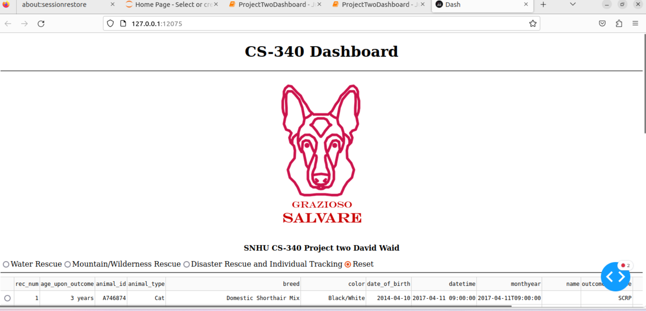

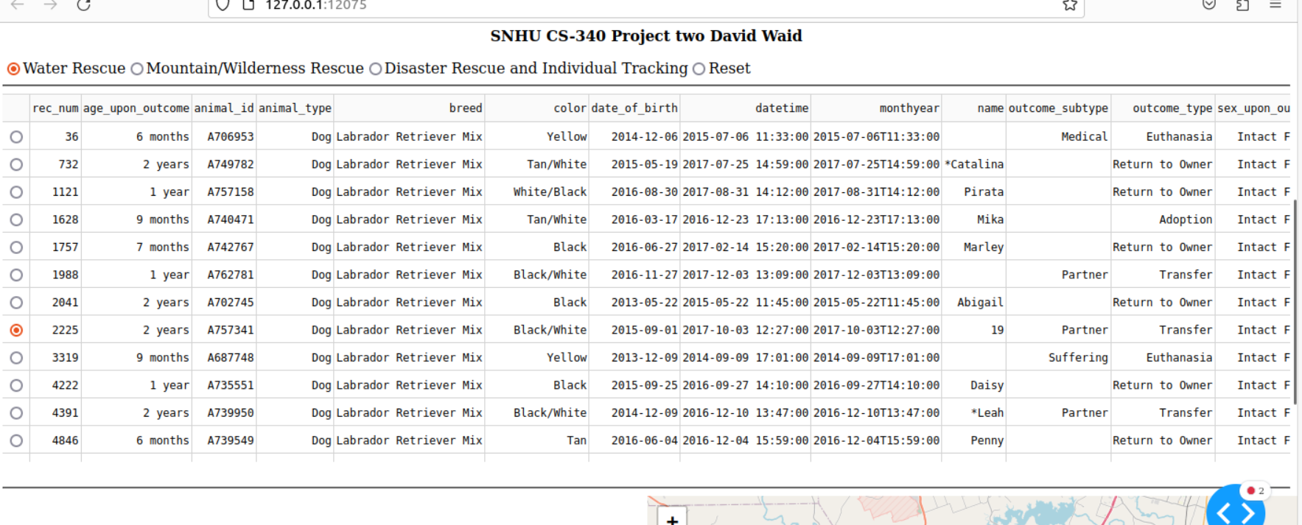  
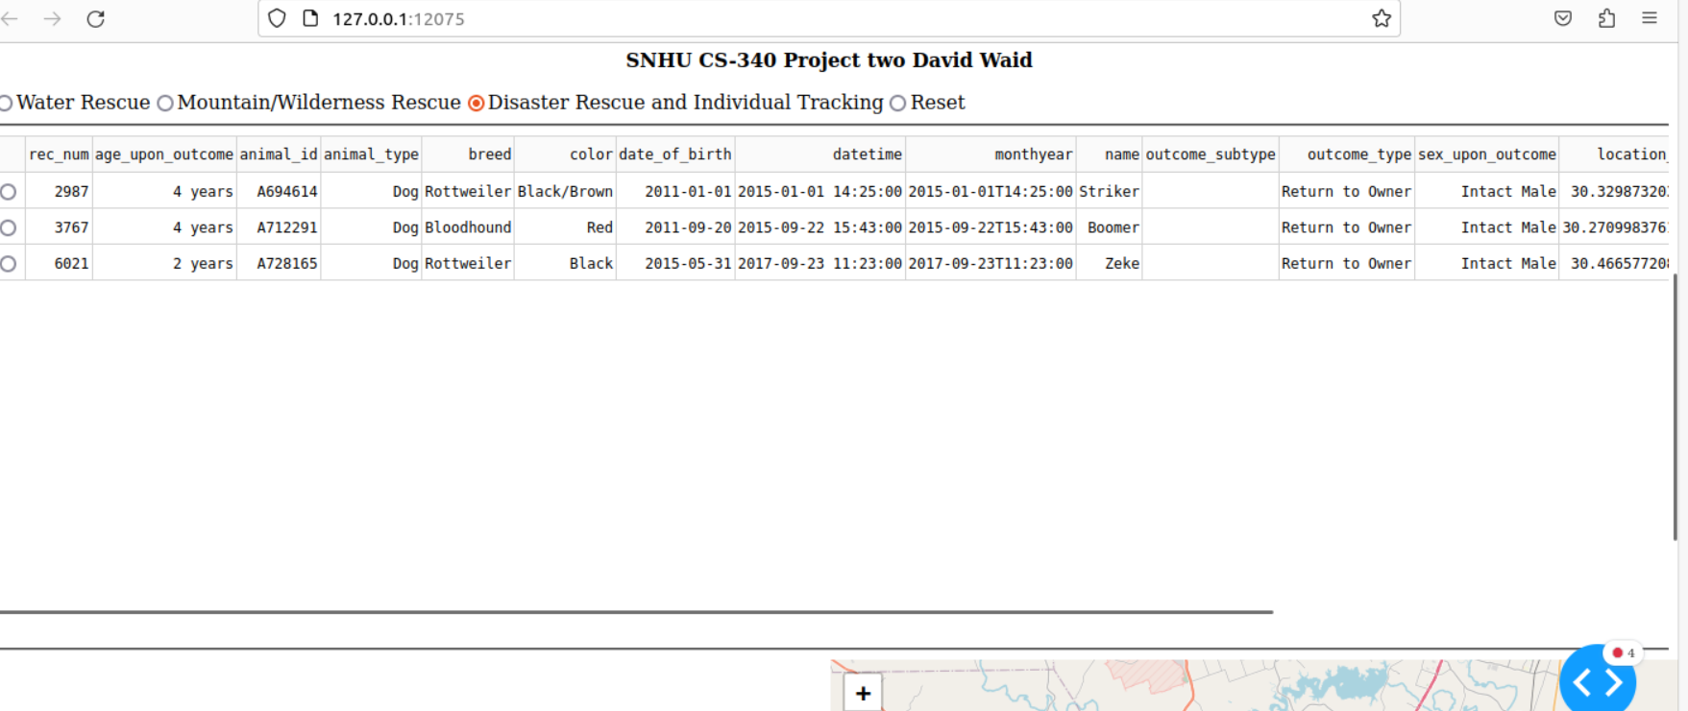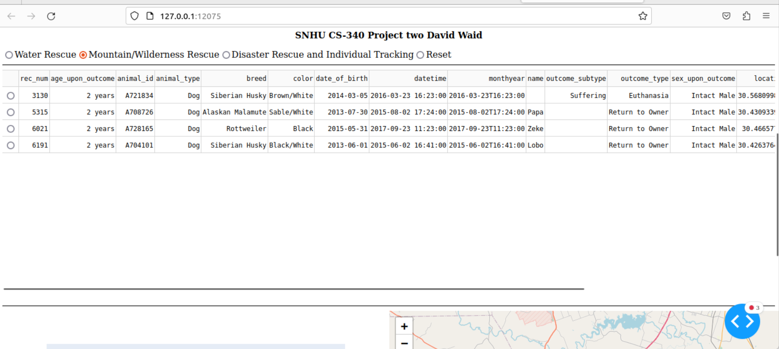

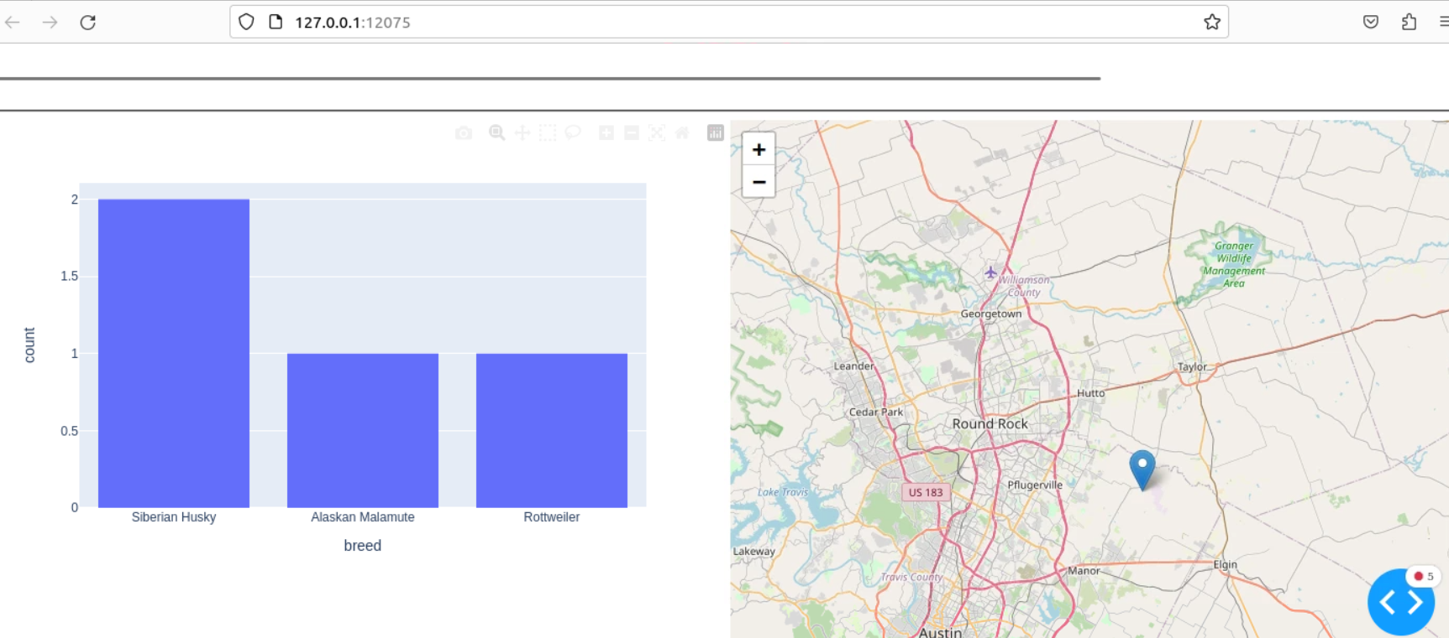

**Describe the tools used to achieve this functionality and a rationale for why these tools were used-**

The CS-340 Dashboard project utilizes a strategic set of tools and technologies to deliver its required functionality. At its core, Python serves as the primary programming language, offering versatility and a vast library ecosystem. This choice is motivated by Python's capability to manage data, construct web applications, and seamlessly integrate with other technologies, making it an ideal foundation for the project.

In the front end, the Dash framework and Plotly are the driving forces behind the user interface and data visualization. Dash, a Python web application framework, enables the creation of interactive components without extensive JavaScript coding. It fosters modular design, simplifying component management. Plotly complements this by providing rich data visualization capabilities, particularly for rendering the histogram and geolocation charts, enhancing the user experience.

Pandas, a powerful data manipulation library for Python, plays a crucial role in structuring and presenting data within the application. It facilitates efficient data handling and offers essential tools for working with structured data, ensuring that the animal shelter records are presented in a user-friendly manner. MongoDB, a NoSQL database, acts as the project's model component. It was chosen for its strength in efficiently managing and querying unstructured data, particularly for diverse animal shelter records. MongoDB's Python driver, PyMongo, streamlines data interaction, while its scalability and JSON-like data storage ensure the system can accommodate future data growth seamlessly. This combination of technologies optimally positions the CS-340 Dashboard to meet the specific requirements of Grazioso Salvare.

**Explain the steps that were taken to complete this-**

In the beginning I read through all of the information on requirements and ensured I knew exactly what was required and that way I could come up with a plan on how to complete these tasks. Then I took my time doing a few fixing a few lines of code and just kept doing that until completion

**Identify any challenges that were encountered and explain how those challenges were overcome-**

The main challenges that I overcame were me not being able to get the filters to properly work. The way that I overcame this was doing self-research on how to add these filters to my Dashboard. Using YouTube videos, I was finally able to find a way to make it work.

Contact

Your name: David Waid